**ISRAEL LANGUAGES**

**https://24x7offshoring.com/**

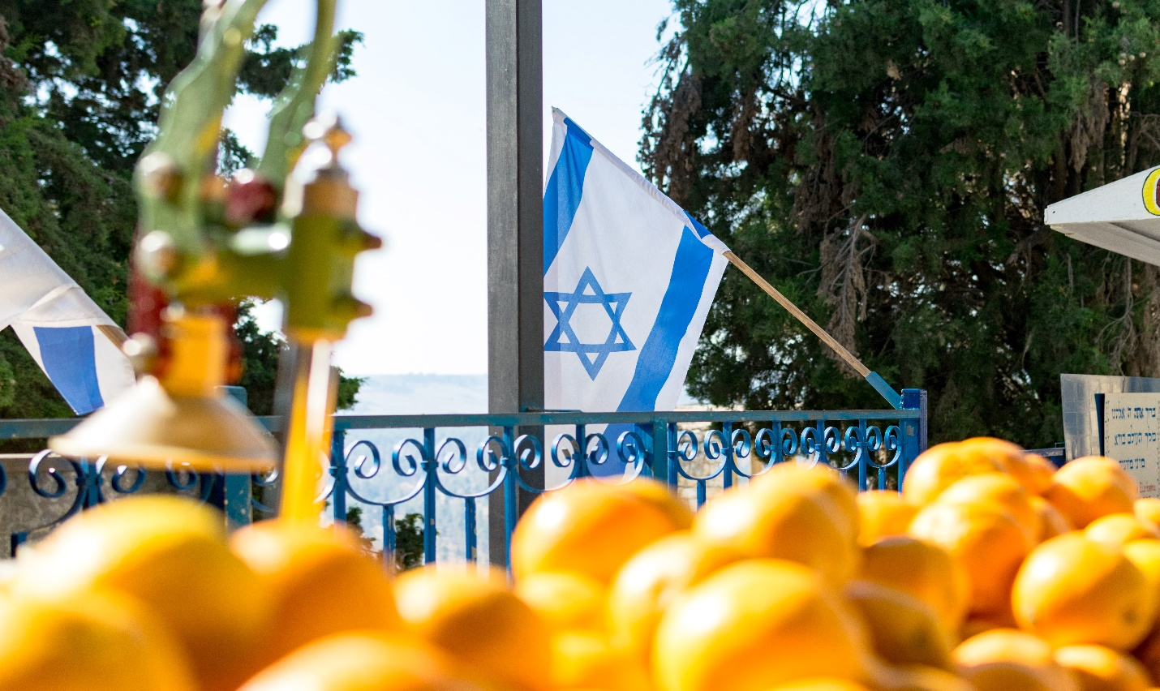 [**http://24x7outsourcing.com/**](http://24x7outsourcing.com/)

**What Languages are spoken in Israel?**

Numerous ethnic gatherings are living in Israel. Israel is situated in the Middle East.

It is a little size territory with a populace of about 8.9 million individuals. Numerous individuals from various societies moved to Israel and the collaboration of various nationalities brought about the development of various dialects.

According to the Israel Central Bureau of Statistics,49% of the populace speaks Hebrew, 15% Russian, 18% Arabic, 20% French, 2% English, and 1.6 % Spanish. Different dialects that are spoken in Israel are 10%. At present English language is educated in schools so Israelis can speak with the worldwide world without any problem.

**Significant dialects of Israel**

According to the 21st version of Ethnologue, there are 34 dialects spoken in Israel. Out of these dialects, 15 dialects are non-native and 19 are native.

The authority dialects of Israel are Hebrew and Arabic. Both of these dialects are spoken by the regular populace of Israel. Hebrew is instructed by Arab instructors in school and the Arabic language is spoken by minorities of the area. English was before the authority language of Israel. Yet, with time, the English language lost its importance somewhat.

**Dialects Spoken In Israel**

There are a plenty of dialects that are spoken in Israel. How about we examine the quantity of dialects that are utilized in Israel.

**Hebrew**

Hebrew is the ordinary communicating in language of Israel.

This language was resuscitated following 150 years, and individuals thought of it as a wonder. The restoration of Hebrew was difficult and it confronted resistance from different dialects, primarily from Yiddish to turn into a urgent language of the Zionist task.

It is additionally considered as the language of a strict faction called Judaism. Middle Easterner schools in Israel encourage the Hebrew language to the kids until they arrive at the 3rd grade. Israeli youngsters need to finish the Hebrew test to get enlisted.

The more established adaptation of Hebrew has taken many advance words from different dialects like Arabic, Latin, and Greek Persian, and numerous different dialects like Akkadian and Canaanite dialects.

The type of Hebrew that is utilized today is impelled as the scriptural language and its contents follow old Hebrew composed structure. The phonation of Modern Hebrew is a reexamined structure made on the Sephardic (Hispano-Portuguese) articulation.

**Arabic**

Arabic is the second authority language of Israel.

It is spoken by 20% of the all-out populace of Israel that incorporates Arab residents of Israel and Jewish individuals from the Arab world. There is a significant lingo of Arab language which is called Levantine Arabic and it is spoken by numerous Israeli Arabs.

The Arabic vernacular that is spoken in Israel is like Bedouin Arabic tongue and Palestinian Arabic. In the Northern piece of Israel, the Lebanese Arabic vernacular is spoken by Druze and Arabs. The more seasoned age of Jews known as Mizrahi Jews communicates in Judeo-Arabic dialects.

**Russian**

Albeit Russian isn't the authority language of Israel. Because of the movement of Russian Jews, it is spoken by 20% of Israelis. Russian is viewed as a significant language in Israel, and a nearby TV station in Israel is working in the Russian language.

**ISRAEL LANGUAGES**

**https://24x7offshoring.com/**

**http://24x7outsourcing.com/**